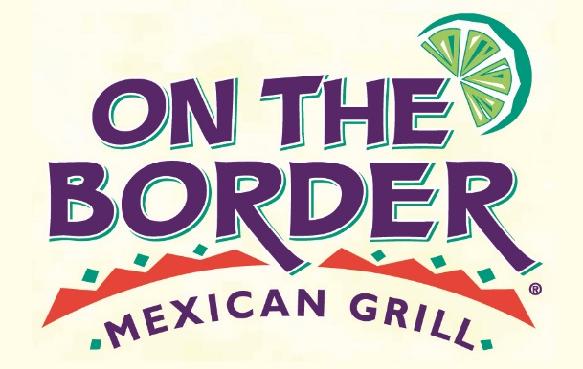

**The Hickman NEST**

**Dine-Out**

and 20% of food and beverage purchases will be donated to The Hickman Nest

Monday, May 6, 2024

4:00 P.M. – 9:00 P.M.

**On The Border Mexican Grill & Cantina**

**10789 Westview ParkwaySan Diego, CA 92126**

**858-530-1130**

**HAPPY HOUR AND OTHER DISCOUNTS DO NOT APPLY**

Present this flyer during your visit on